

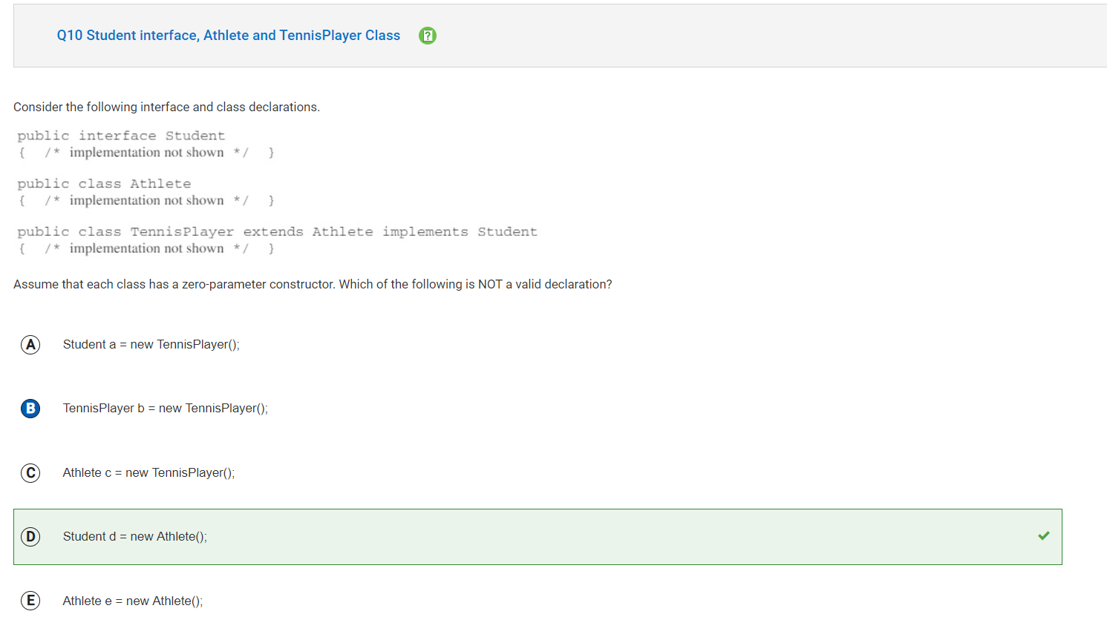

**B is incorrect because a variable of type TennisPlayer can reference an object of type TennisPlayer. (interface no longer part of APCSA exam)**

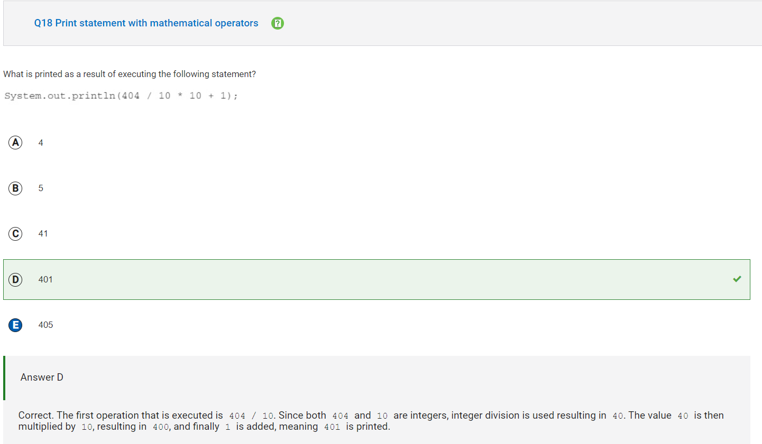

**E is incorrect because that would be the answer if it was a float data type division, but since it is data type int the answer is 401.**

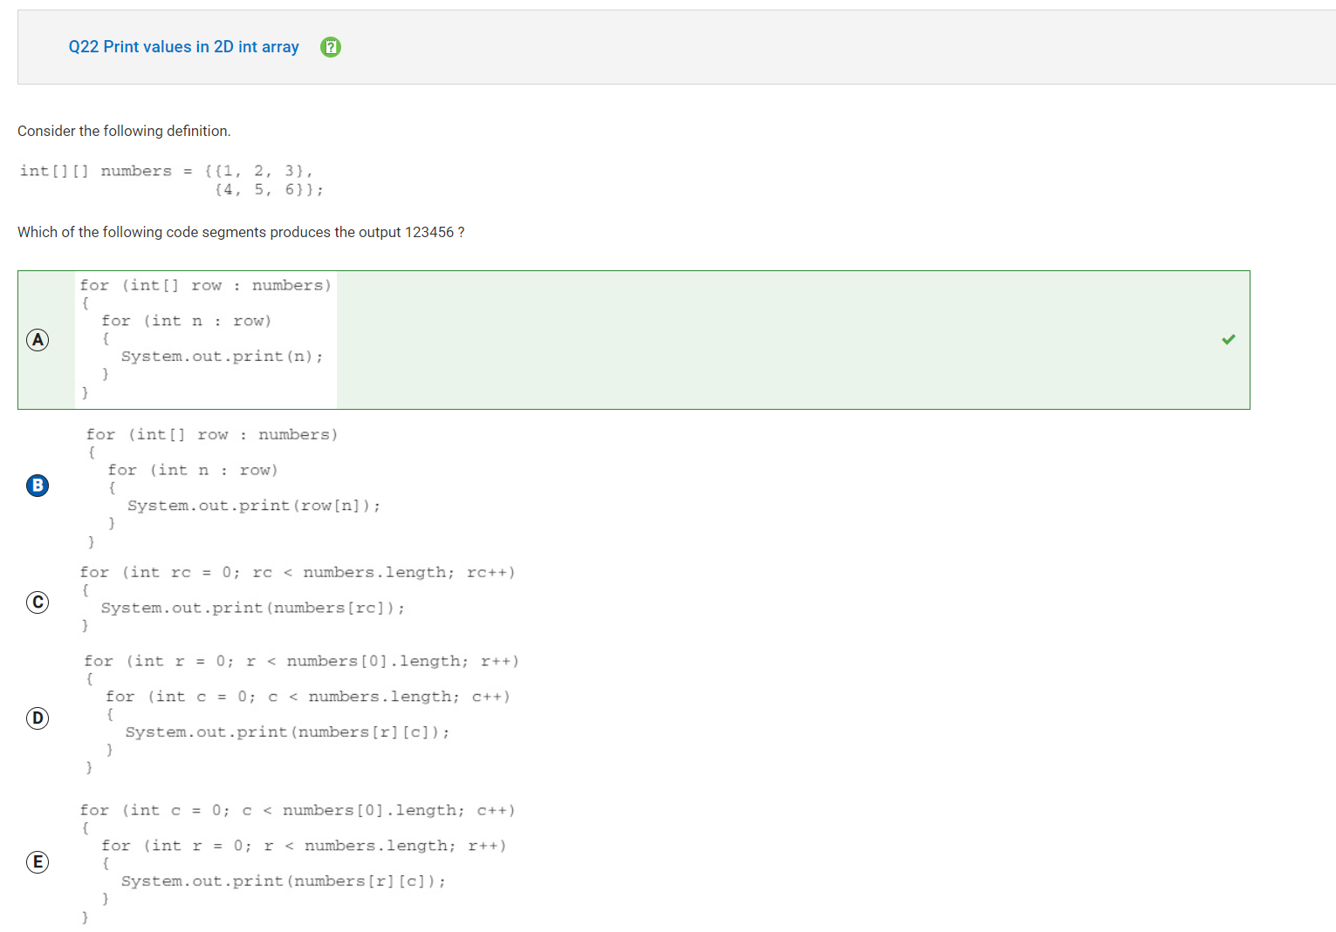

**B is incorrect because the values in each row of numbers would be used to access the element at these indices. For the first iteration of the outer loop: row would be {1, 2, 3}.**

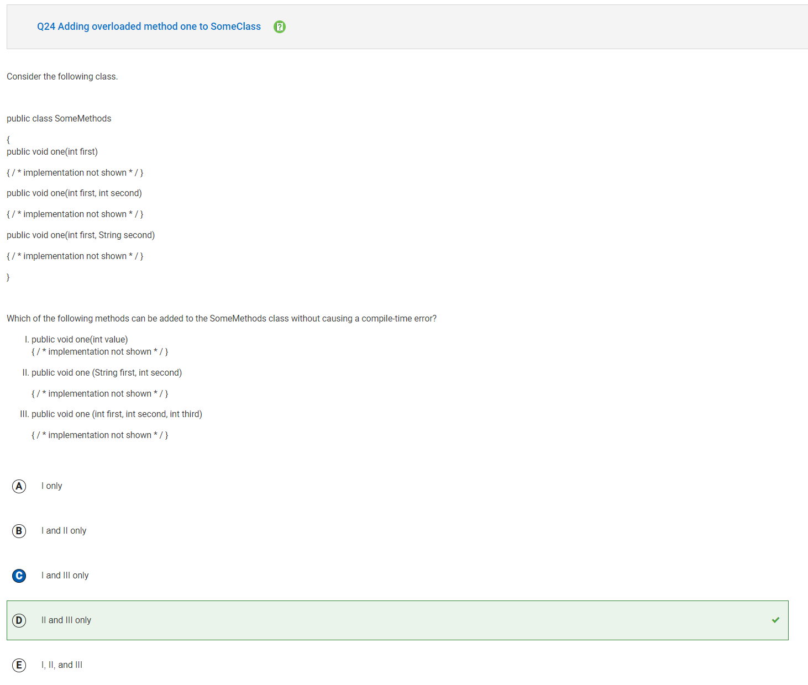

**C is incorrect because 1 will cause a compile-time error if added to the SomeMethods class because it has the same method signature as public void one (int first)**